LAB REPORT

Lab Assignment 7: Banker’s Algorithm

1. Objective
- To implement the Banker’s Algorithm in C for avoiding deadlocks in a multi-process environment.
- To check if the system is in a safe state after resource allocation.
- To simulate how processes request and release resources while ensuring deadlock avoidance.

2. Theory
Deadlock is a condition in operating systems where processes are stuck waiting for resources indefinitely. To prevent this, we use Deadlock Avoidance algorithms, one of the most important being the Banker’s Algorithm.
- Banker’s Algorithm works by checking if resource allocation to a process leaves the system in a safe state (meaning there exists a sequence of process execution where every process can finish).
- If granting a request leads to an unsafe state, the system denies the allocation to avoid potential deadlocks.
Key Concepts:
- Available[ ] – Array that shows the number of available resources of each type.
- Max[ ] [ ] – Maximum demand of each process.
- Allocation[ ] [ ] – Current allocation of resources to each process.
- Need[ ] [ ] – Remaining resources needed by each process (Need[ I ] [ j ] = Max[ I ] [ j] – Allocation [ I ][ j ]).
- Safe Sequence – An order in which processes can execute without leading to deadlock.

3. Tools and Commands Used
- gcc – GNU Compiler for compiling the C program.
- Linux Terminal – For execution and testing.
- C programming language – For algorithm implementation.

4. Procedure
- Input Resource Data
  - Accept the number of processes and resource types.
  - Input the Max matrix, Allocation matrix, and the Available resources.

- Calculate the Need Matrix
  - Compute Need = Max – Allocation for each process.

- Implement Banker’s Algorithm
  - Initialize Finish[] for all processes as false.
  - Search for a process whose Need ≤ Available and Finish == false.
  - If found, allocate its resources back to Available and mark Finish = true.
  - Repeat until all processes are marked true or no such process is found.

- Check for Safe State
  - If all processes are able to finish, the system is in a safe state and display the safe sequence.
  - If not, declare the system is in an unsafe state.

5. Program

a. Setup the directory.

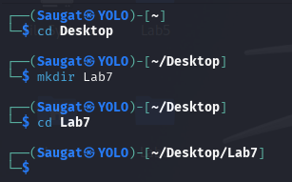

b. Write the Banker’s Algorithm code in C-Language.



c. Write the Banker’s Algorithm Code.

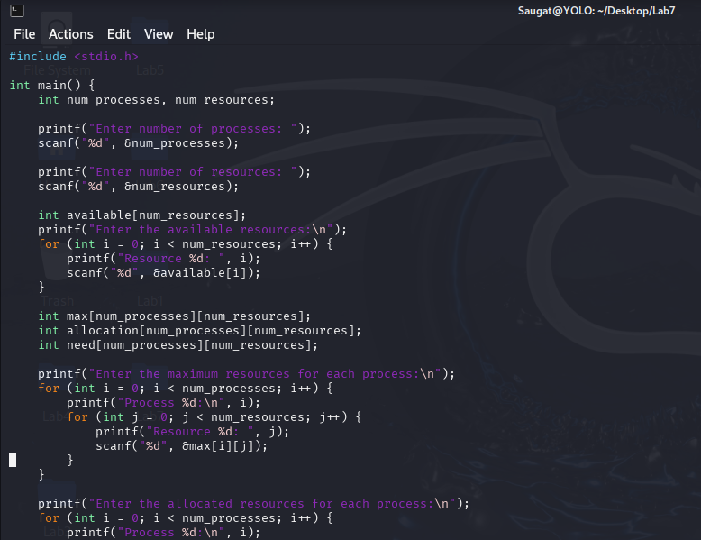

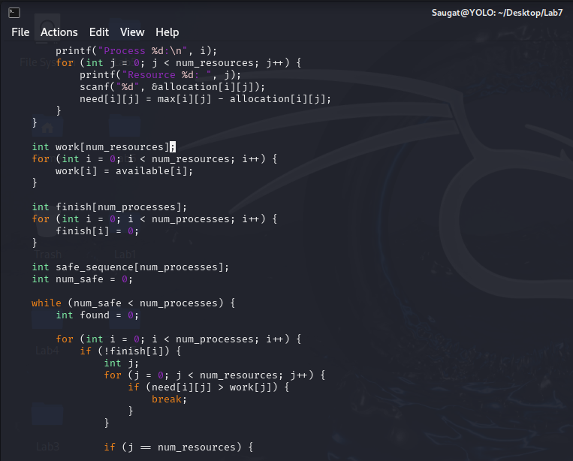
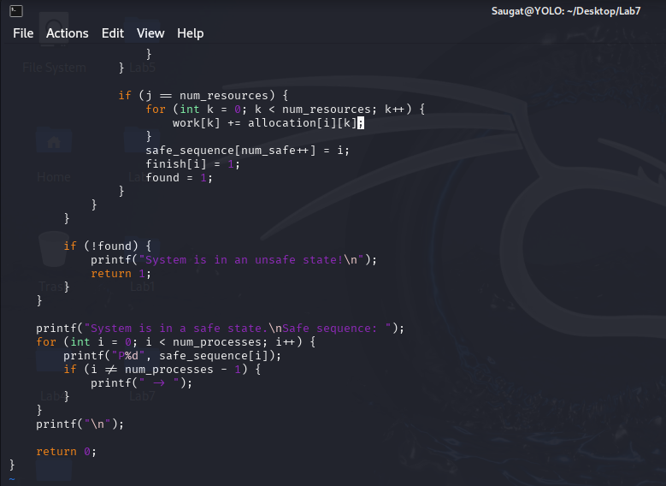

d. Compile the C-file.


e. Execute the file.
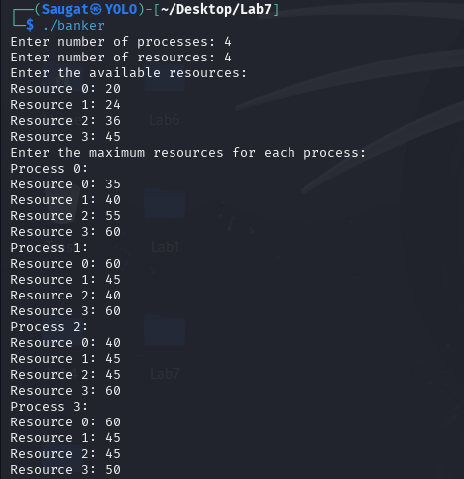
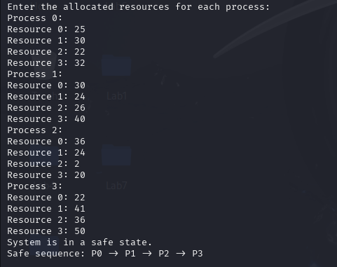

6. Conclusion
In this lab, we successfully implemented the Banker’s Algorithm to simulate deadlock avoidance in operating systems. The program determined whether the system is in a safe state and produced a safe sequence for process execution if possible. This lab reinforced the importance of resource allocation strategies and their role in preventing deadlocks in multi-processing environments.

